SIMATS ENGINEERING (SAVEETHA SCHOOL OF ENGINEERING)
Department of Computer Science and Engineering
CO2 ASSESSMENT TOOL 1 – Scenario-Based Requirement Analysis

Course Code: | CSA10 | Course Title: | Software Engineering
CO Assessed: | CO2 | Assessment: | Assessment Tool 2 – Scenario-Based Requirement Analysis
Weightage: | 20% | Total Marks: | 25
CO2 Statement: | Scenario based requirement analysis for software Requirement Specification(SRS)
Student Name: | K Sujith Sai Vighnesh | Reg. No.: | 192311199
Date: | 04-08-2026 | Duration: | 60 minutes

Code of Conduct
I K Sujith Sai Vighnesh – 192311199 certify that this submission is my original work and that I have adhered to the guidelines specified for this assessment. I understand that any violation of academic integrity rules will result in disciplinary action.
Signature of the Student: K Sujith Sai Vighnesh
Annexure A – Scenario-Based Requirement Analysis
Instructions to Students:
Each student will be assigned an individual software project problem statement. Analyze the given scenario and prepare a complete Software Requirement Analysis document by following the steps below.

Question
Based on the assigned problem statement, perform a Scenario-Based Requirement Analysis and prepare a Software Requirement Specification (SRS) document. Your analysis should include the following:
- Study and Analyze the Scenario
  - Carefully understand the given problem statement.
  - Identify the business domain, stakeholders, existing challenges, and system objectives.
- Identify Functional and Non-Functional Requirements
  - List all functional requirements required by the proposed system.
  - Identify suitable non-functional requirements such as performance, security, reliability, usability, scalability, maintainability, and availability.
- Identify Actors and Use Cases
  - Identify all primary and secondary actors interacting with the system.
  - List the major use cases associated with each actor.
  - Draw a Use Case Diagram representing the interactions between actors and the system.
- Prepare the Software Requirement Specification (SRS)
Develop an SRS document containing:
  - Introduction
  - Problem Description
  - Scope of the System
  - Functional Requirements
  - Non-Functional Requirements
  - Use Case Descriptions
  - Data Requirements
  - External Interface Requirements
  - System Features
- Identify Assumptions and Constraints
  - List the assumptions considered while developing the system.
  - Identify technical, operational, economic, legal, and time-related constraints affecting the project.
- Validate Requirement Completeness and Consistency
  - Verify whether all stakeholder requirements have been addressed.
  - Check for ambiguity, redundancy, inconsistency, and missing requirements.
  - Suggest improvements to enhance the quality and completeness of the requirement specification.
Rubrics for Calculation
Criteria | Excellent (4 Marks) | Good (3 Marks) | Satisfactory (2 Marks) | Needs Improvement (1 Mark)
Scenario Understanding and Problem Analysis | Demonstrates thorough understanding of the scenario, stakeholders, objectives, and business context with clear analysis. | Demonstrates good understanding with minor omissions. | Basic understanding with limited analysis. | Poor understanding; major aspects missing or incorrect.
Functional and Non-Functional Requirement Identification | Clearly identifies comprehensive, accurate, and well-classified functional and non-functional requirements. | Identifies most requirements with minor classification errors. | Identifies only basic requirements; several omissions. | Requirements are incomplete, inaccurate, or poorly classified.
Actor Identification and Use Case Modeling | Correctly identifies all relevant actors and use cases; use case diagram is complete, accurate, and follows UML standards. | Most actors and use cases identified; diagram has minor errors. | Limited actors/use cases identified; diagram partially correct. | Actors/use cases missing or incorrect; diagram absent or inaccurate.
Software Requirement Specification (SRS) Documentation | SRS is well-structured, complete, professionally organized, and includes all required sections. | SRS is organized with minor missing sections or formatting issues. | SRS includes only essential sections with limited detail. | SRS is incomplete, poorly organized, or lacks essential components.
Assumptions, Constraints, and Requirement Validation | Clearly identifies realistic assumptions and constraints; validates requirements for completeness, consistency, and ambiguity with appropriate justification. | Identifies most assumptions and constraints; validation is adequate. | Limited assumptions/constraints; validation is superficial. | Assumptions, constraints, and validation are missing or incorrect.

Criteria | Mark
Scenario Understanding and Problem Analysis | /5
Functional and Non-Functional Requirement Identification | /5
Actor Identification and Use Case Modeling | /5
Software Requirement Specification (SRS) Documentation | /5
Assumptions, Constraints, and Requirement Validation | /5
TOTAL | /5

SCENARIO-BASED REQUIREMENT ANALYSIS
Software Requirement Specification (SRS)
AI-Powered Smart Disaster Relief Resource Allocation and Coordination Platform
Annexure A — Scenario-Based Requirement Analysis Deliverable

1. Scenario Understanding and Problem Analysis

1.1 Business Domain
The system operates in the Disaster Management and Humanitarian Relief domain, at the intersection of public-sector emergency response, NGO relief operations, and logistics/supply-chain management. It draws on AI/ML, Geographic Information Systems (GIS), Cloud Computing, and the Internet of Things (IoT) to support time-critical decision-making during natural disasters (floods, earthquakes, cyclones, wildfires, etc.).

1.2 Stakeholders
Stakeholder | Interest / Role
Government Disaster Management Authority | Owns overall response strategy, approves resource release, consumes reports for policy decisions.
NGOs / Relief Organizations | Supply and distribute food, medicine, and shelter materials; coordinate with other agencies.
Emergency Responders / Rescue Teams | Perform rescue and first-aid operations; rely on severity data and task assignments.
Shelter Managers / Camp Administrators | Manage shelter capacity and occupancy status.
Logistics & Transport Providers / Drivers | Move relief supplies using optimized, safe routes.
Affected Communities / Citizens | End beneficiaries; need visibility of aid, shelters, and how to request help.
Volunteers / Field Responders | Collect ground-truth data and assist distribution.
Donor / Funding Agencies | Require transparency on how funds and resources are utilized.
Platform Administrators / IT Team | Maintain system availability, security, and data integrity.

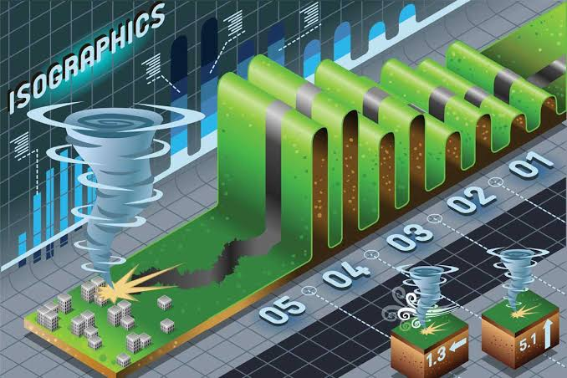

1.3 Existing Challenges
- Fragmented communication between government agencies, NGOs, and responders leads to duplicated or missed efforts.
- Inaccurate, manual demand estimation causes over- or under-supply of critical resources.
- No real-time visibility into inventory levels, shelter capacity, or affected locations.
- Manual route planning ignores road damage and live traffic, delaying delivery.
- Lack of a common coordination platform results in unequal and inefficient distribution of aid.
- Absence of consolidated reporting slows post-event review and accountability.

1.4 System Objectives
- Monitor disaster relief resources in real time.
- Predict resource demand using AI.
- Optimize relief distribution routes.
- Coordinate multiple relief agencies.
- Monitor shelter occupancy.
- Generate emergency logistics reports.
- Improve disaster response efficiency and reduce distribution delays.



2. Functional and Non-Functional Requirements

2.1 Functional Requirements
ID | Requirement | Module
FR-01 | The system shall record and update relief inventory quantities (food, medicine, shelter items, equipment) in real time. | Inventory
FR-02 | The system shall automatically generate a low-stock alert when an item falls below its configured threshold. | Inventory
FR-03 | The system shall allow field responders to submit inventory usage updates via a mobile application, including in low-connectivity conditions. | Inventory
FR-04 | The system shall ingest GIS and IoT sensor data (weather, water level, structural) to compute a disaster severity score per zone. | Severity Assessment
FR-05 | The system shall display a severity heat map of affected zones, updated as new data arrives. | Severity Assessment
FR-06 | The system shall use an AI model to forecast resource demand per region based on severity score, population, and historical relief data. | AI Prediction
FR-07 | The system shall display demand forecasts with a confidence indicator, viewable per region. | AI Prediction
FR-08 | The system shall compute optimized delivery routes considering road damage, closures, and live traffic conditions. | Logistics
FR-09 | The system shall provide turn-by-turn navigation to drivers and recalculate routes when conditions change. | Logistics
FR-10 | The system shall track relief vehicle locations on a live map using GPS data. | Logistics

2.2 Non-Functional Requirements
Category | Requirement
Performance | Inventory and severity updates shall propagate to dashboards within 5 seconds; AI demand forecasts shall be generated within 10 seconds of request.
Security | All data in transit and at rest shall be encrypted (TLS 1.2+/AES-256); access shall be governed by role-based permissions and MFA for admin/government accounts.
Reliability | Core coordination services shall achieve 99.5% uptime, with automatic failover for the alerting and inventory services during active disaster events.
Usability | Field and citizen-facing mobile interfaces shall be usable by non-technical users, support low-literacy iconography, and function in low-bandwidth (2G/3G) conditions.
Scalability | The platform shall support at least a 10x surge in concurrent users and data volume during a major disaster without service degradation.
Maintainability | The system shall use a modular, API-based architecture allowing individual modules (routing, AI model, reporting) to be updated independently.
Availability | The platform shall remain accessible on mobile devices with intermittent connectivity through offline data caching and background sync.

3. Actors and Use Cases

3.1 Primary Actors
Actor | Description
Relief Coordinator | Oversees inventory, demand forecasts, and agency coordination.
Field Responder / Volunteer | Updates ground data, submits inventory usage, sends alerts.
Logistics Manager / Driver | Plans and executes delivery routes; tracks vehicles.
Shelter Manager | Manages shelter occupancy and capacity.
Government Official | Assigns zones/tasks, reviews reports and analytics, sets policy.
NGO / Agency Coordinator | Coordinates their agency's resources and tasks on the shared dashboard.
Citizen | Searches for shelters and submits aid requests.
System Administrator | Manages user accounts, roles, and system configuration.

3.2 Secondary / System Actors
- IoT / GIS Sensor Feed — supplies weather, water-level, structural, and satellite imagery data for severity assessment.
- Mapping / Routing Service — external GIS/traffic provider used for route optimization.
- SMS / Push Notification Gateway — delivers alerts to users without requiring an active app session.

3.3 Use Cases per Actor
Actor | Associated Use Cases
Relief Coordinator | Monitor Resource Inventory; Predict Resource Demand; Coordinate Relief Agencies; Generate Logistics Reports
Field Responder / Volunteer | Submit Field Data Updates; Send/Receive Emergency Alerts
Logistics Manager / Driver | Optimize Distribution Routes; Track Delivery Vehicles
Shelter Manager | Update Shelter Occupancy
Government Official | Assess Disaster Severity; Assign Zones & Tasks; View Analytics Dashboard
NGO / Agency Coordinator | Coordinate Relief Agencies; Predict Resource Demand; Manage User Accounts (own agency staff)
Citizen | Search Nearby Shelters; Request Aid / Report Need
System Administrator | Manage User Accounts; Authenticate Users; Configure Alert Thresholds

3.4 Use Case Diagram
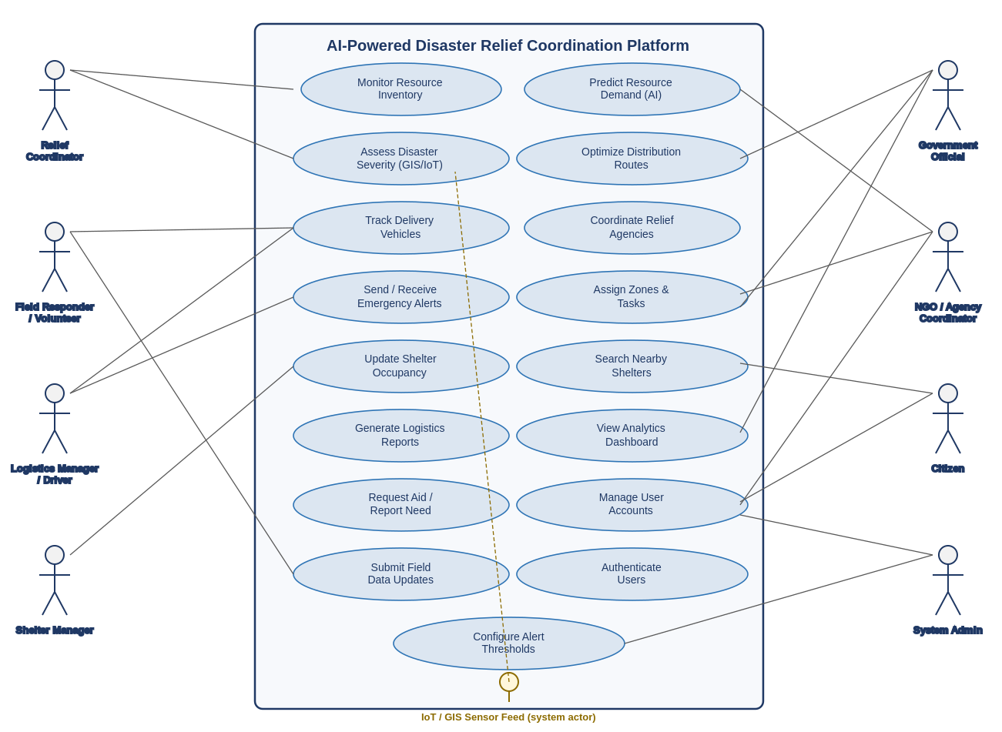
Figure 1: Use Case Diagram — AI-Powered Disaster Relief Coordination Platform
.
4. Software Requirement Specification (SRS)

4.1 Introduction

Purpose
This document specifies the software requirements for the AI-Powered Smart Disaster Relief Resource Allocation and Coordination Platform. It is intended to guide design, development, and testing, and to serve as an agreed reference between stakeholders and the development team.

Intended Audience
Government disaster management authorities, NGO/relief agency leadership, the development and QA team, project sponsors, and system administrators.

Document Conventions
Functional requirements are prefixed FR-##; non-functional requirements are grouped by quality attribute. "Shall" denotes a mandatory requirement.

4.2 Problem Description
Disaster relief operations currently suffer from fragmented communication, inaccurate manual demand estimation, and inefficient resource allocation. Agencies lack real-time visibility into available resources and affected locations, causing unequal and delayed distribution of aid. The proposed platform addresses this by centralizing severity assessment, demand prediction, inventory monitoring, logistics optimization, and multi-agency coordination in a single cloud-based system.

4.3 Scope of the System

In Scope
- Real-time inventory monitoring and alerting.
- AI-based severity assessment and demand prediction.
- Route optimization and vehicle tracking for relief logistics.
- Multi-agency coordination dashboard and task/zone assignment.
- Shelter occupancy tracking and citizen-facing shelter search.
- Automated reporting and analytics.

Out of Scope (Phase 1)
- Direct financial disbursement or donation payment processing.
- Autonomous drone/robot dispatch for physical delivery.
- Long-term post-disaster reconstruction planning.

4.4 Functional Requirements
See Section 2.1 for the complete, numbered list of functional requirements (FR-01 through FR-20), covering Inventory, Severity Assessment, AI Prediction, Logistics, Coordination, Shelter Management, Reporting, Citizen Services, and User Management.

4.5 Non-Functional Requirements
See Section 2.2 for non-functional requirements covering performance, security, reliability, usability, scalability, maintainability, availability, and interoperability.

4.6 Use Case Descriptions
UC-01: Monitor Resource Inventory
Actor(s): Relief Coordinator, Field Responder
Description: Allows authorized users to view and update real-time inventory levels of relief supplies.
Preconditions: User is authenticated with Inventory module access.
Main Flow:
1. User logs into the platform.
2. User navigates to the Inventory dashboard.
3. System displays current stock levels by item and location.
4. User records a stock inbound/dispatch transaction.
5. System updates the inventory record and timestamps the change.
6. System recalculates stock status and triggers a low-stock alert if applicable.
Alternate / Exception Flow: If connectivity is lost, the mobile app queues the update locally and syncs when connectivity is restored.
Postconditions: Inventory levels are updated and visible to all authorized users in real time.
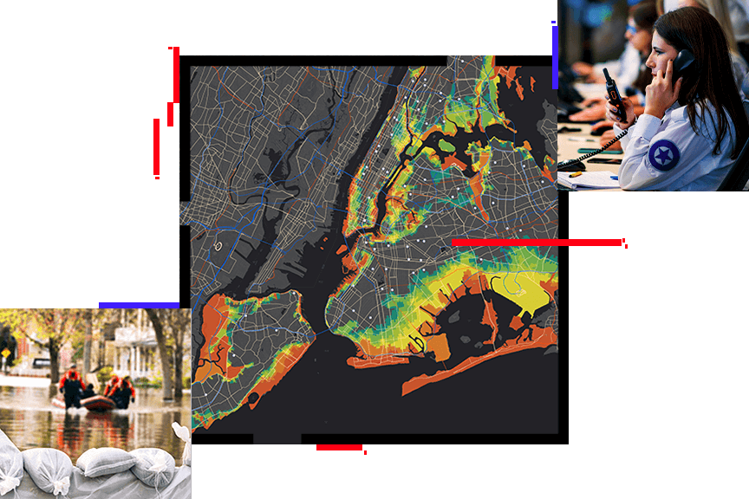
UC-02: Predict Resource Demand
Actor(s): Relief Coordinator, NGO/Agency Coordinator
Description: Generates an AI-based forecast of resource requirements for a region.
Preconditions: Severity score and population data for the region are available.
Main Flow:
1. Coordinator selects a region and requests a demand forecast.
2. System retrieves severity score, population, and historical relief data.
3. AI model computes predicted quantities for food, medicine, and shelter items.
4. System displays the forecast with a confidence score.
5. Coordinator uses the forecast to plan resource allocation.
Alternate / Exception Flow: If insufficient historical data exists for a region, the system falls back to a rule-based estimate and flags it as low-confidence.
Postconditions: A demand forecast is available to inform inventory and logistics planning.
UC-03: Optimize Distribution Routes
Actor(s): Logistics Manager, Driver
Description: Calculates the fastest safe delivery route to a destination, accounting for road damage and traffic.
Preconditions: Destination and current road-condition data are available.
Main Flow:
1. Logistics Manager enters shipment origin and destination.
2. System retrieves live traffic and road-damage data.
3. Routing engine computes the optimal route, excluding blocked/damaged roads.
4. System displays the route and estimated arrival time to the driver.
5. Driver begins the delivery; system tracks vehicle position along the route.
Alternate / Exception Flow: If a road becomes blocked mid-route, the system recalculates and alerts the driver within 30 seconds.
Postconditions: Shipment follows an optimized route with real-time tracking visible to the Relief Coordinator.
UC-04: Coordinate Relief Agencies
Actor(s): Relief Coordinator, NGO/Agency Coordinator, Government Official
Description: Provides a shared, role-based dashboard for multiple agencies to view resources, tasks, and avoid duplication.
Preconditions: Agencies are registered and assigned roles/zones in the system.
Main Flow:
1. Agency user logs into the shared dashboard.
2. System displays resources, severity, and active tasks scoped to the user's role/zone.
3. Government Official assigns a zone or task to an agency.
4. System notifies the assigned agency in real time.
5. Agencies update task status as work progresses, visible to all participants.
Alternate / Exception Flow: If two agencies attempt to claim the same task, the system locks the task to the first confirmed assignment and notifies the second agency of the conflict.
Postconditions: All participating agencies have a consistent, real-time view of resources and responsibilities.
UC-05: Update Shelter Occupancy
Actor(s): Shelter Manager, Citizen
Description: Tracks live shelter occupancy and lets citizens find shelters with available capacity.
Preconditions: Shelter is registered in the system with a maximum capacity.
Main Flow:
1. Shelter Manager logs the current number of occupants.
2. System recalculates remaining capacity.
3. System marks the shelter "full" if capacity is reached.
4. Citizen searches for nearby shelters.
5. System returns only shelters with available capacity, sorted by distance.
Alternate / Exception Flow: If a shelter manager does not update occupancy for a defined period, the system flags the record as stale and notifies the coordinator.
Postconditions: Citizens are directed only to shelters with confirmed available space.


4.7 Data Requirements
Entity | Key Attributes
Resource / Inventory Item | Item ID, category, quantity, unit, location, minimum threshold, last updated timestamp.
Disaster Zone | Zone ID, geographic boundary, population, severity score, severity classification, last assessed timestamp.
Demand Forecast | Forecast ID, zone ID, predicted quantities per item category, confidence score, generated timestamp.
Shipment / Delivery | Shipment ID, origin, destination, assigned vehicle, route, status, estimated/actual arrival time.
Shelter | Shelter ID, location, maximum capacity, current occupancy, status (open/full/closed).
Agency | Agency ID, name, type (Government/NGO), assigned zones, contact details.
User Account | User ID, name, role, agency affiliation, contact details, authentication credentials.
Alert | Alert ID, type, severity, sender, recipients, message, timestamp, acknowledgment status.

4.8 External Interface Requirements

User Interfaces
- Web-based dashboard for coordinators, government officials, and administrators.
- Mobile application (Android/iOS) for field responders, drivers, shelter managers, and citizens, with offline-capable data entry.

Hardware Interfaces
- IoT sensors (water level, structural, weather stations) transmitting readings to the platform.
- GPS modules in delivery vehicles and mobile devices for location tracking.

Software Interfaces
- Third-party GIS/mapping and routing APIs for satellite imagery, road networks, and traffic data.
- Weather data provider API for forecast and hazard alerts.
- Cloud storage and database services for persisting inventory, shelter, and reporting data.

Communication Interfaces
- HTTPS/REST APIs for standard client-server communication.
- WebSocket connections for real-time dashboard updates.
- MQTT (or equivalent lightweight protocol) for IoT sensor data ingestion.
- SMS/push notification gateway for alerts to users without an active data connection.

4.9 System Features
Feature | Priority | Summary
Real-Time Inventory Monitoring | High | Live tracking and alerting on relief supply stock levels.
AI Severity Assessment | High | GIS/IoT-driven scoring of disaster impact per zone.
AI Demand Prediction | High | Forecasts resource needs from severity and population data.
Route Optimization | High | Computes safe, fast delivery routes avoiding damaged roads.
Multi-Agency Coordination Dashboard | High | Shared, real-time view of resources and task assignments.
Shelter Occupancy Tracking | Medium | Live shelter capacity for managers and citizens.
Emergency Logistics Reporting | Medium | Automated, exportable performance and distribution reports.
Citizen Aid Request & Shelter Finder | Medium | Citizen-facing tools to request help and locate shelters.
User & Access Management | High | Role-based authentication and audit logging.

5. Assumptions and Constraints

5.1 Assumptions
- Basic cellular or satellite connectivity is available in most affected areas, even if intermittent.
- Participating agencies are willing to share resource and location data on a common platform.
- Field staff and citizens have access to a smartphone or basic mobile device.
- Government bodies will provide population and administrative-boundary data for severity and demand modeling.
- GIS, satellite imagery, and weather data providers offer sufficiently timely feeds for disaster response.
- IoT sensor networks are deployed and maintained in at least the highest-risk zones.

5.2 Constraints
Type | Constraint
Technical | Must integrate with heterogeneous, sometimes legacy, agency systems and data formats; network conditions in disaster zones may be degraded or intermittent.
Operational | System must operate 24/7 during active disaster response with minimal downtime; field staff require training on mobile data entry.
Economic | Cloud infrastructure, satellite imagery, and third-party API licensing costs must fit within the project/agency budget.
Legal | Must comply with data privacy regulations for citizen and beneficiary data, and cross-border data-sharing agreements where international NGOs are involved.
Time | The platform should be deployable ahead of anticipated disaster seasons, limiting the time available for extensive field trials.

6. Requirement Validation — Completeness and Consistency

6.1 Stakeholder Objective Traceability
Problem Statement Objective | Addressed By
Monitor disaster relief resources in real time. | FR-01, FR-02, FR-03; UC-01
Predict resource demand using AI. | FR-06, FR-07; UC-03
Optimize relief distribution routes. | FR-08, FR-09, FR-10; UC-04
Coordinate multiple relief agencies. | FR-11, FR-12, FR-13; UC-05
Monitor shelter occupancy. | FR-14, FR-15; UC-06
Generate emergency logistics reports. | FR-16, FR-17
Improve disaster response efficiency / reduce delays. | NFR-Performance, NFR-Scalability; all optimization features
All eight objectives and expected outcomes from the problem statement map to at least one functional requirement or use case, confirming coverage completeness at the objective level.

6.2 Ambiguity, Redundancy, and Inconsistency Check
Issue Identified | Resolution
"Real time" was undefined in the original problem statement. | Quantified in NFR-Performance as a 5-second propagation target for dashboards and a 10-second target for AI forecasts.
Overlap between FR-11 (shared dashboard) and FR-17 (analytics dashboard) risked duplicate scope. | FR-11 scoped to operational, live coordination data; FR-17 scoped to historical/aggregate analytics — kept as distinct features with a shared data layer.
No requirement originally addressed offline use, despite disaster-zone connectivity being unreliable. | Added FR-03 (offline-capable field updates) and an Availability NFR covering offline caching and background sync.
No requirement covered accountability/traceability of coordination actions. | Added FR-20 (audit logging) to support transparency, one of the stated expected outcomes.
Citizen-facing needs were implicit in the original objectives but not explicit. | Added FR-15 and FR-18 to make citizen-facing shelter search and aid requests explicit requirements.

6.3 Suggested Improvements
- Define explicit Service Level Agreements (SLAs) with each participating agency for data-sharing timeliness and accuracy.
- Add a requirement for AI model explainability/bias monitoring, given the humanitarian impact of demand-prediction errors.
- Add multilingual and low-literacy UI support for citizen-facing features, given diverse affected populations.
- Introduce a formal data-retention and anonymization policy for citizen and beneficiary data to strengthen legal compliance.
- Add a periodic reconciliation requirement to detect and resolve inventory or occupancy discrepancies between field reports and system records.


